

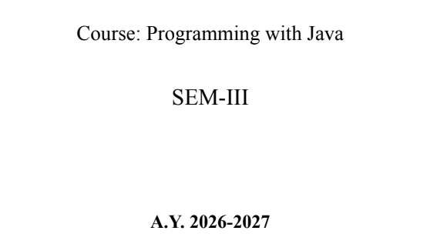

NAME: BHOOMI VIJAYVARGIYA
BATCH: A2
PRN: 25070122062

ASSIGNMENT No : 7
TITLE : Implement a Java program to demonstrate inheritance and interfaces using suitable real-world examples.
Problem Statement: Implement a Java program to demonstrate inheritance and interfaces using suitable real-world examples.
CODE:
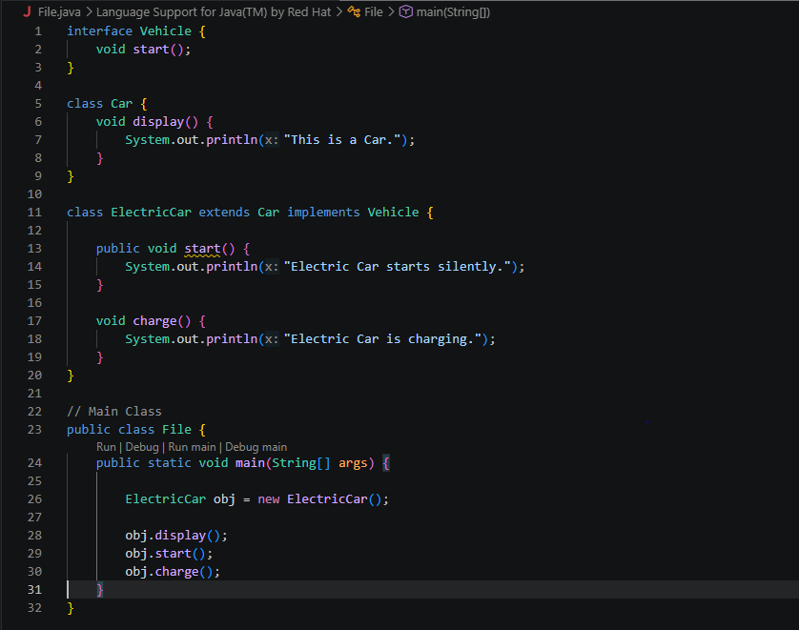
OUTPUT:
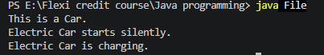
Learning Objectives: To implement inheritance and interfaces for achieving code reusability and abstraction.
Theory:
Inheritance allows one class to acquire the properties and methods of another class, promoting code reuse and reducing redundancy. Java supports single inheritance through the extends keyword. Interfaces define a contract that implementing classes must follow, enabling abstraction and multiple inheritance of type. Together, inheritance and interfaces support polymorphism and modular software development. They are fundamental concepts of object-oriented programming.
Outcome
• Learned how inheritance enables code reuse by allowing child classes to inherit common features from a parent class.
• Learned how interfaces provide a common structure that different classes can implement.
Conclusion
This experiment demonstrates the effective use of inheritance and interfaces in Java to implement Object-Oriented Programming concepts. These features promote code reusability, abstraction, modularity, and maintainability, making programs more organized and scalable. By applying these concepts to real-world examples, a better understanding of Java OOP principles and software design is achieved.

Exercise
1.Create a Shape application where Circle and Rectangle inherit from Shape and calculate area.
CODE:
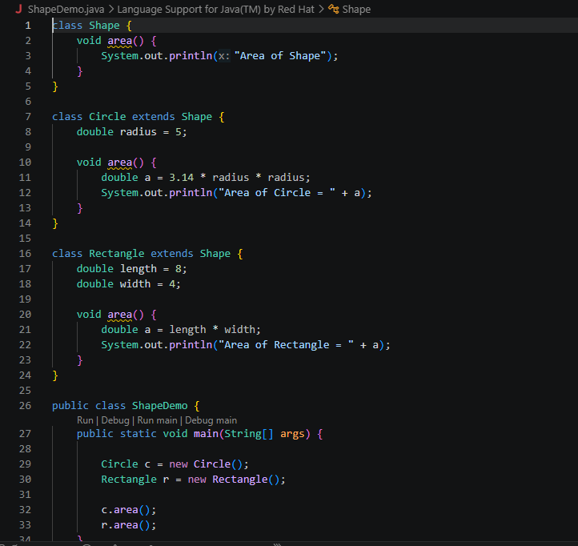
OUTPUT
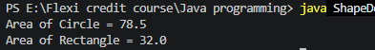
2. Develop a E-Commerce Product System where electronic, clothing, and grocery products inherit common properties and implement product interfaces.
